**Project 3:**

#### Working with volumes

Step 1: Creating a windows instance

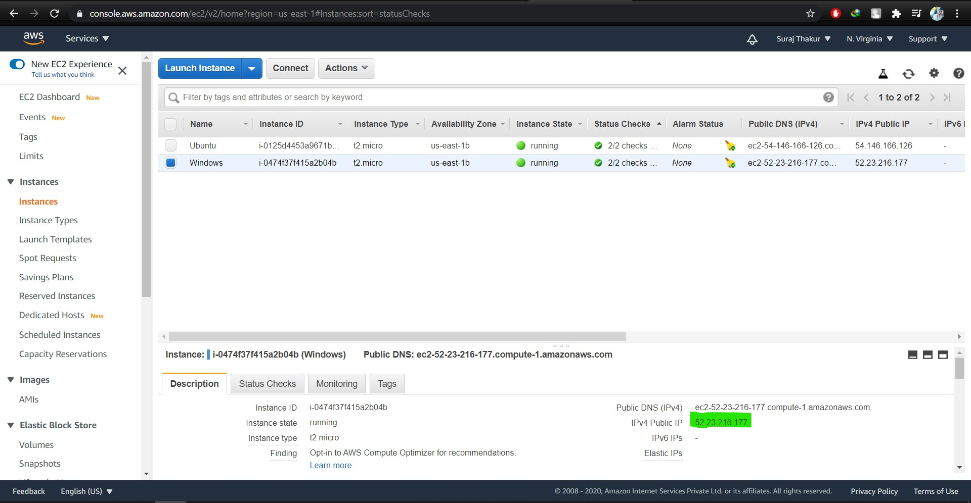

Step 2: Creating a volume in the same region as the windows machine.

Default volume:

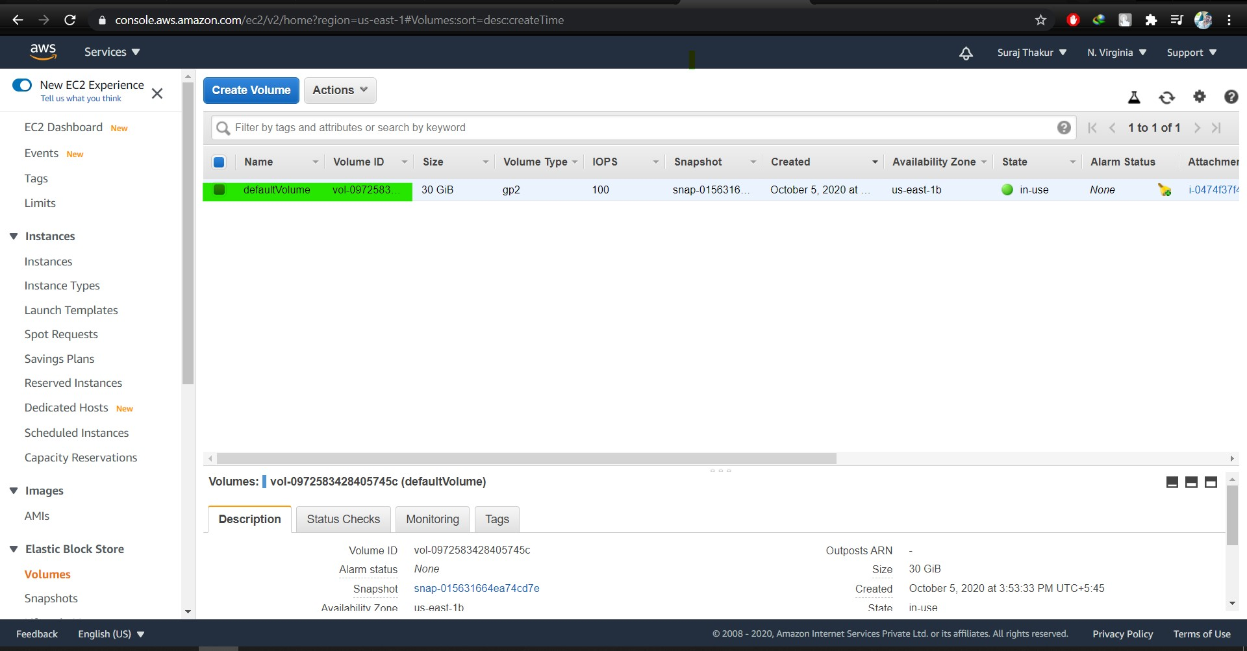

Creation of new volume:

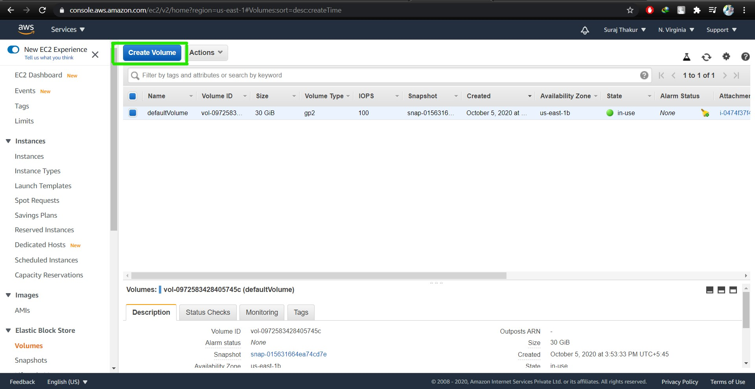

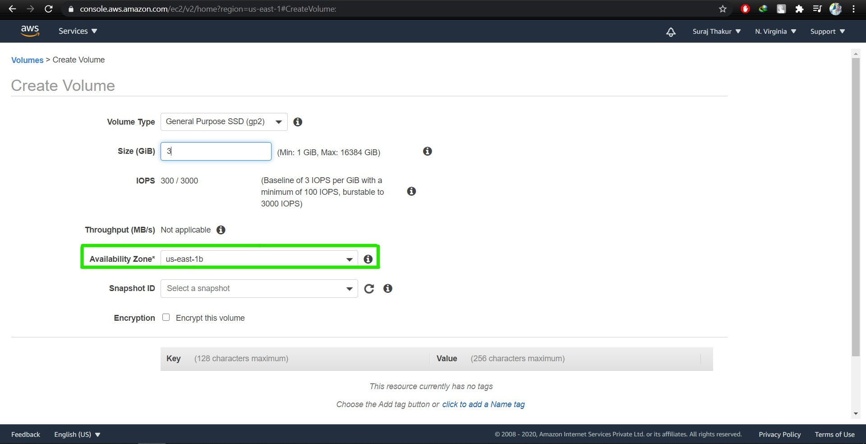

Note: The Availability zone of the volume should be same as the machine

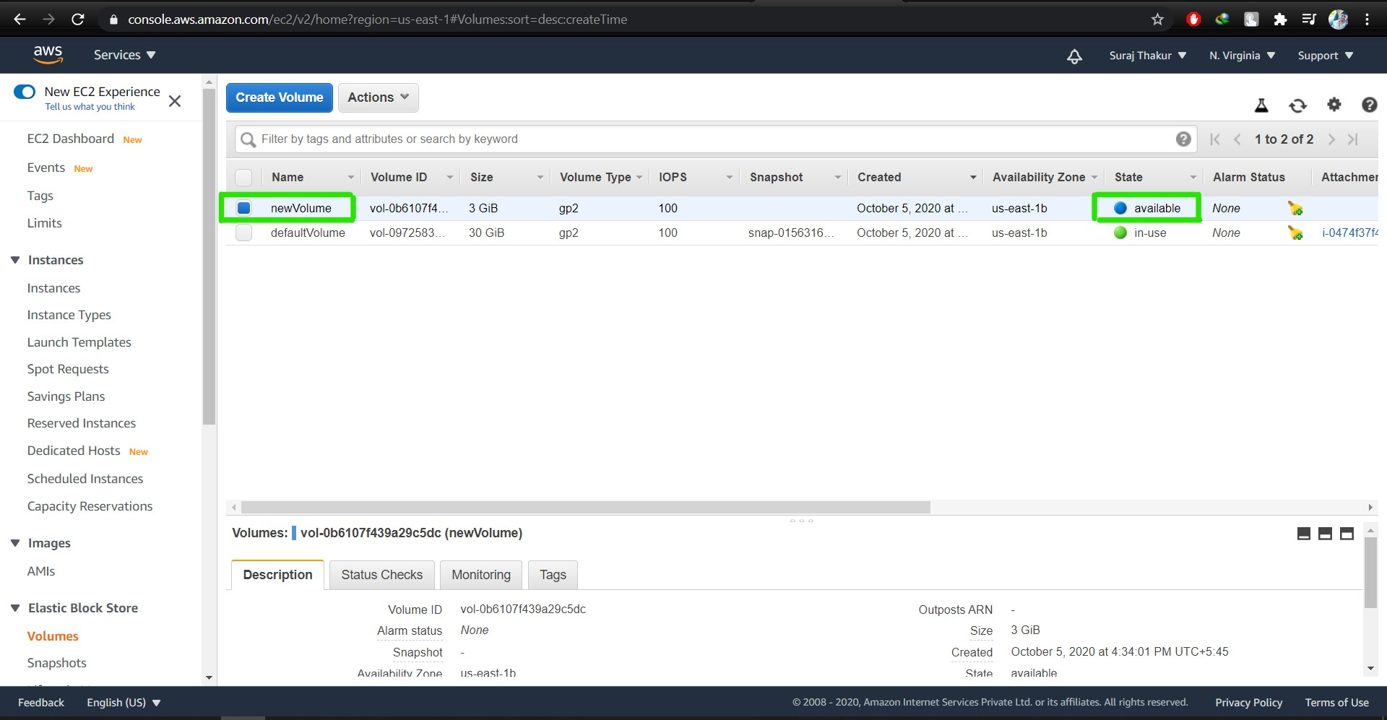

Step 3: Attach the newly created volume to the existing windows machine

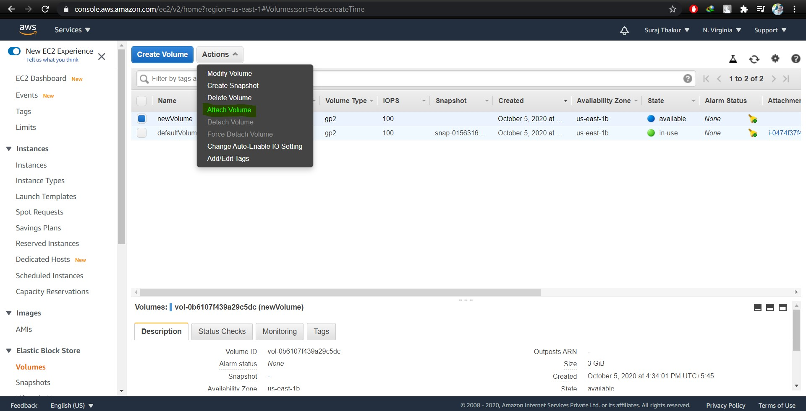

Step 4: From Server Manager bring the volume online. Once the EBS is online, create a new volume.

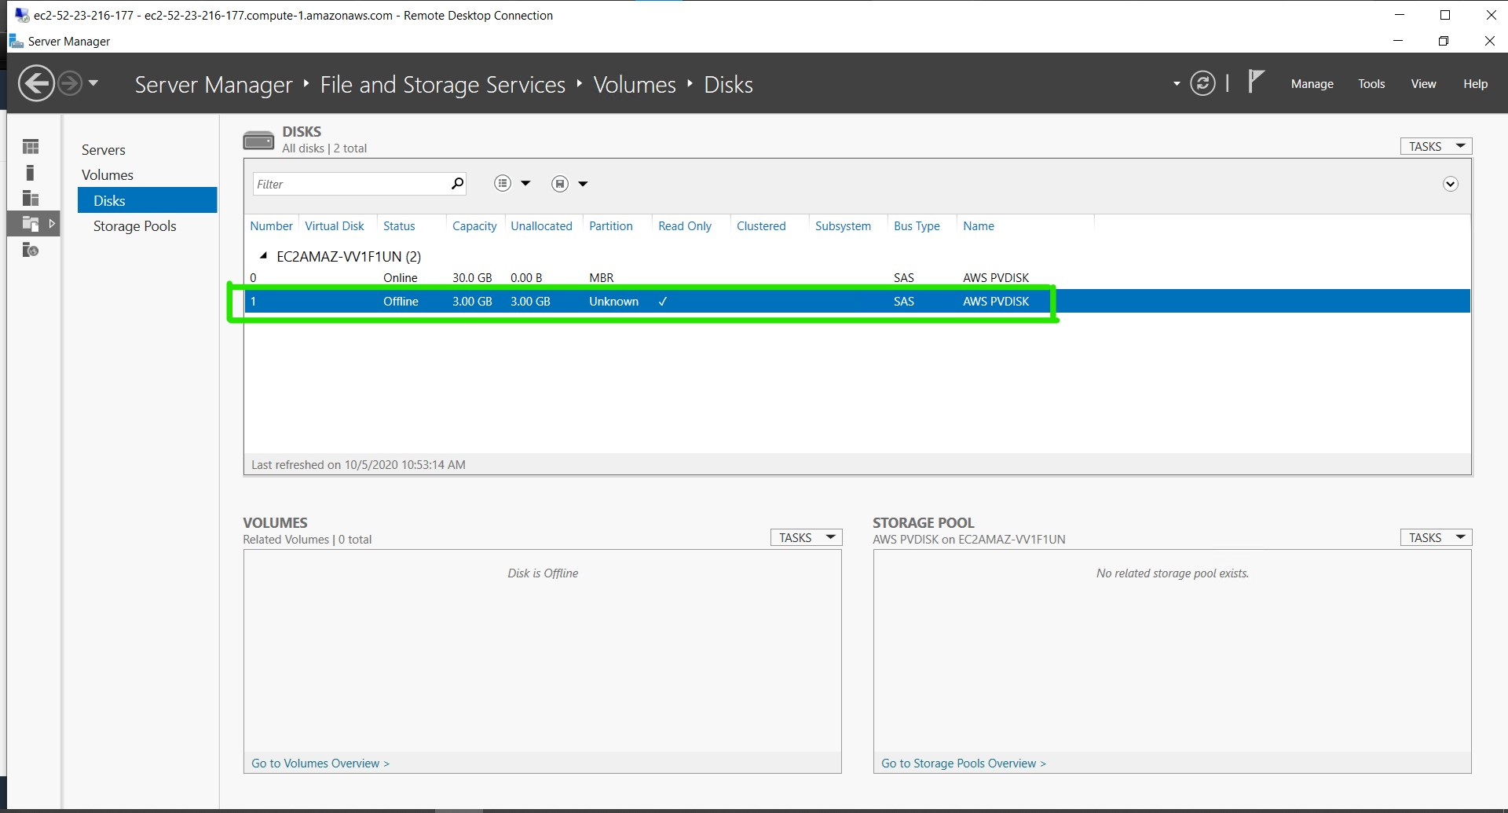

Step 5: Check if the volume is mounted successfully

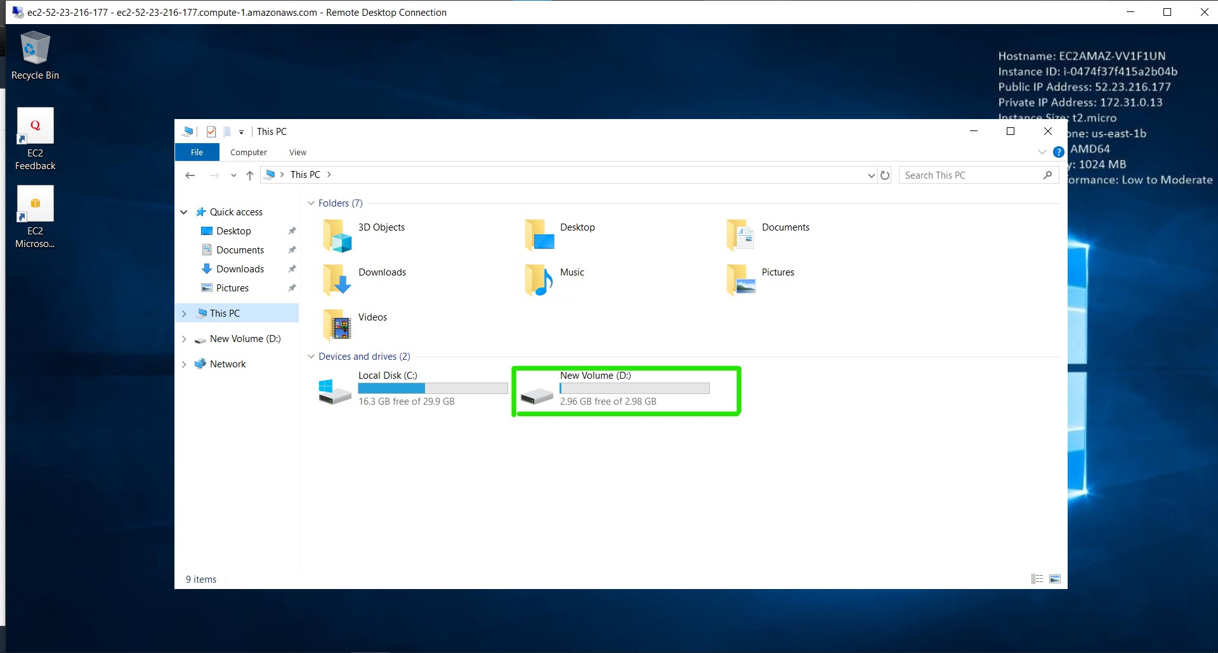

Step 6: Delete the volume

